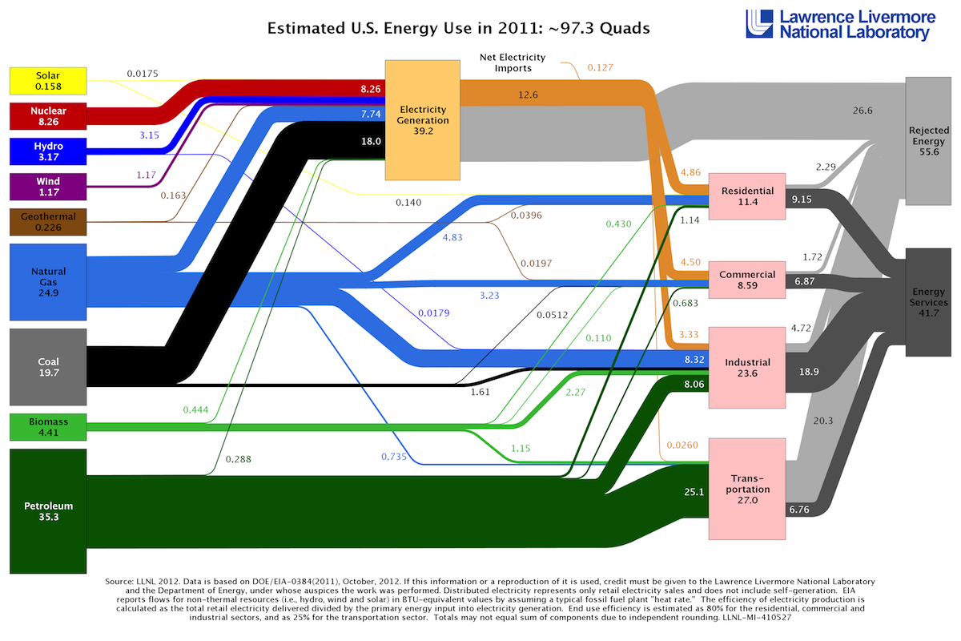
1- Based on the LLNL energy flow figure, reproduced below, [x1] quads of coal energy were used to produce electricity in the US in 2011.

Answer: ______________

2- Based on the LLNL energy flow figure, reproduced below, [x1] quads of natural gas energy were used for residential applications in the US in 2011.

Answer: __________

For the following reaction:
3 CO + 7 H₂ → C₃H₈ + 3 H₂O
This reaction is:
exothermic

endothermic

both

neither

3- For the following reaction:

3 CO + 7 H₂ → C₃H₈ + 3 H₂O
The reaction is called:
water-gas production reaction

water-gas shift reaction

Fischer-Tropsch process

steam methane reforming

4- How much CO₂ in metric tonnes is produced by the combustion of 440 metric tonnes of propane (C₃H₈)?
Less than 1000

1000-1100

1100-1200

1200-1300

1300-1400

1400-1500

More than 1500

5- What is the Carnot efficiency of an engine if the heat source is 600˚C and the heat sink is 25˚C?
Less than 30%

Between 30% and 40%

Between 40% and 50%

Between 50% and 60%

Between 60% and 70%

Higher than 70%

6- Consider the previous reaction. How many grams of CO₂ are produced?
Less than 50

50-80

80-110

110-140

More than 140

7- Which of the following would be considered biofuels?
Trash

Corn Ethanol

Cellulosic Ethanol

Biodiesel

Soybean oil

Wood pellets

Biogas from a landfill

